(2) Novel Jewels (Aditya Birla Group): Overview | LinkedIn

John Barnabas | LinkedIn

Novel Jewels (Aditya Birla Group)
Retail Luxury Goods and Jewelry

Mumbai, Maharashtra

Overview
Welcome to Novel Jewels, a dynamic venture of the esteemed Aditya Birla Group, pioneering the realm of fine jewellery with innovation and elegance. As a new entrant in the jewellery industry, we bring a fresh perspective and a commitment to excellence that reflects the rich heritage of our parent conglomerate. At Novel Jewels, we embark on a journey of crafting exquisite pieces with precision and passion. Our creations blend traditional craftsmanship with contemporary designs, catering to the discerning tastes of modern connoisseurs. Driven by a culture of creativity and collaboration, our team is dedicated to delivering unparalleled quality and service, ensuring each customer's experience is nothing short of extraordinary. We believe in embracing challenges and pushing boundaries to bring forth unique collections that inspire and captivate. With a focus on integrity, innovation, and customer-centricity, Novel Jewels aims to set new benchmarks in the jewellery industry while upholding the values and legacy of the Aditya Birla Group. Join us on this exhilarating journey as we unveil a new Jewel in the corporate world.

Website
www.indriya.com

Phone
+912269047600Phone number is +912269047600

Industry
Retail Luxury Goods and Jewelry

Company size
501-1,000 employees
809 associated members LinkedIn members who’ve listed Novel Jewels (Aditya Birla Group) as their current workplace on their profile.

Headquarters
Mumbai, Maharashtra

Specialties
Fine Jewelry and Bridal Jewelry

Aditya Birla Group Announces Rs 5,000 cr Investment to Establish 'Novel Jewels' Branded Jewellery Retail Stores in India

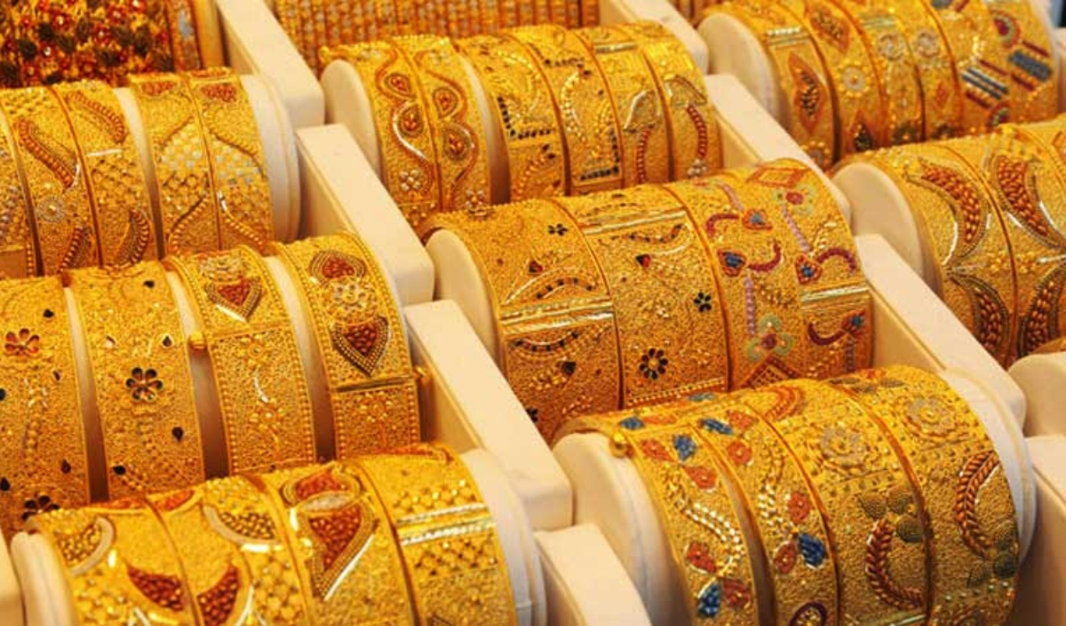
Conglomerate Aditya Birla Group revealed in a media release that it will invest Rs 5,000 crore to establish a new branded jewellery brand called 'Novel Jewels'. The company's plan involves the creation of large-format jewellery retail stores throughout the country, featuring in-house jewellery brands.
"Aditya Birla Group's entry into the branded jewellery retail sector represents a significant milestone in our long-standing tradition of building businesses based on trust. This venture is a strategic decision that enables us to explore new avenues of growth and expand our footprint in the dynamic Indian consumer market," stated Kumar Mangalam Birla, Chairman of Aditya Birla Group.
Birla added, "This initiative will leverage Aditya Birla Group's extensive expertise in lifestyle retail and deep understanding of consumer preferences." The company intends to assemble a new leadership team with expertise in retail and product categories to develop the jewellery brand.
With the gems and jewellery market contributing approximately 7 percent to India's GDP, the jewellery sector is projected to reach $90 billion by 2025, as it undergoes a gradual shift from an unorganized to an organized industry. Aditya Birla Group has recently ventured into the paints and B2B e-commerce segments for building materials, preceding their entry into the jewellery market in the past two years.
Short answer:
👉 There is no publicly disclosed single “top consultant” officially announced for the ₹5,000 crore Aditya Birla Group ‘Novel Jewels’ retail venture.
But here’s the real picture (important) 👇

1. This is NOT a consultant-led project
- The jewellery entry (Novel Jewels / Indriya) is a strategic internal business initiative of the group.
- It is being driven by in-house leadership + retail experts, not by a single external consulting firm like McKinsey/BCG publicly.
- The group announced this as a $600M / ₹5,000 crore investment to build its own branded retail chain (Aditya Birla Group)
👉 Meaning:
This is a “build internally + hire industry talent” model, not “outsourced strategy consulting”.

2. Key known leadership (not consultants)

👤 Kumar Mangalam Birla
- Strategic decision-maker behind entering jewellery retail
- Driving diversification into new consumer categories (Wikipedia)

👤 Shantiswarup Panda
- Leads marketing & brand positioning for Indriya/Novel Jewels
- Responsible for brand building and consumer strategy (LinkedIn)

3. External consultants (Indirect / ecosystem level)
There is no official named “top consultant”, but based on available signals:

Example:
- Jatinder Nayyar
  - Retail expansion consultant engaging with premium jewellery brands
  - Not officially confirmed as main consultant, but part of ecosystem discussions (LinkedIn)

4. What’s REALLY happening (insight)
This project follows a typical large conglomerate retail playbook:
Layer | Who drives it
Strategy | Internal board + chairman
Brand & marketing | In-house leadership
Store expansion | Retail consultants (multiple, not one)
Design & merchandising | Industry hires
Operations | Internal + retail experts
👉 So expecting a single “top consultant” is the wrong mental model.

5. Key takeaway (important for you)
If you’re analyzing this from a strategy / career / architecture lens:
- This is a capability-building play, like:
  - Reliance Trends
  - Tata Titan (Tanishq)
- Winning factors:
  - Brand positioning
  - Retail footprint
  - Supply chain + sourcing
  - Customer experience
👉 Not consultant-driven, but execution-heavy business build

If you want deeper insight
I can break this into:
- Full org structure of Novel Jewels
- Likely consulting firms involved (hidden layer)
- Comparison with Tanishq vs Reliance vs Birla strategy
- Or how YOU can enter such roles (strategy / CPDO path)
Just tell me 👍

